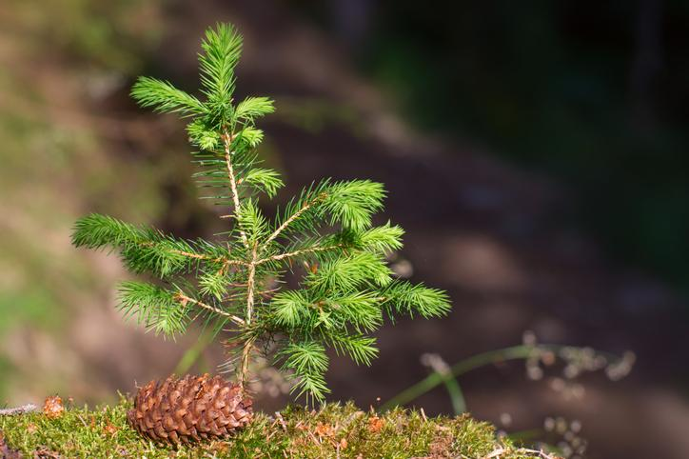
DCLA Annual Tree Sale is Here!

A variety of native trees and shrubs are available for $3 each for members, $4 each for non-members.
Place your order and pay now for Spring delivery.
Follow this link for tree sale details.
Deadline has been extended!

Orders must be received by Tuesday November 29th

